LEXINGTON Mercury Long Life Bed

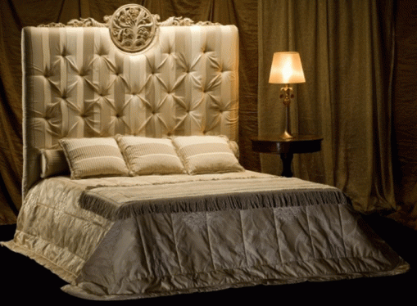

|  |
| --- |
| **DESCRIPTION** |
| LEXINGTON introduces a wooden filled with hard form bed with an antique long back. This set of bed is sure to create the perfect look in any home. The rich form treated with spring mattress creates an astonishing look which makes it perfect for any room of the house. Your guests will love this comfortable mood lifting bed. |

|  |  |  |
| --- | --- | --- |
| **Price** | **3000$** | |
| **Dimensions** | **H** x **W** x **L** | **20in x 65in x 70in** |
| **Features** | **Super spring form mattress is strong enough to hold and adjust to extra weight which is good for the body. The deep size and high back of the bed gives you a complete support which is good for the health.** | |
| **Finished** | **Dotted Print** | |
| **Available in** | **White and Golden** | |